Blog:
Size matters. Rules and Control.

Of course it does. If you buy a wardrobe and it won’t go through your front door you’re snookered. Unless you like your clothes kept in the garden.
From the smallest sports car to the biggest motorbike, size has always been important.

Small is beautiful. Big is best.
For every statement there is a paradox and so it is with rules.

Give me a rule and I will move heaven and earth to see how it can be broken, remoulded, improved.
I may have been born a female in Britain but my mind has a distinctly French accent to it. Or as someone once joked about the French.
Ah oui, it works in practice but will it work in theory?

So where am I going with all this?

The rule book.
The one that says a novel must be at least 80,000 words before a publisher will look at it.
But don’t worry, a publisher won’t look at it anyway unless it is submitted by an agent.
And an agent will only look at one genre.
Find a genre and stick to it a well meaning friend once said to me.
And have cornflakes everyday for breakfast for the rest of your life ... Not going to happen.
Then there is format.
You can’t mix and match. It is either, a novel, a documentary, or a screenplay. Boring.

See NEXT by Michael Crichton.

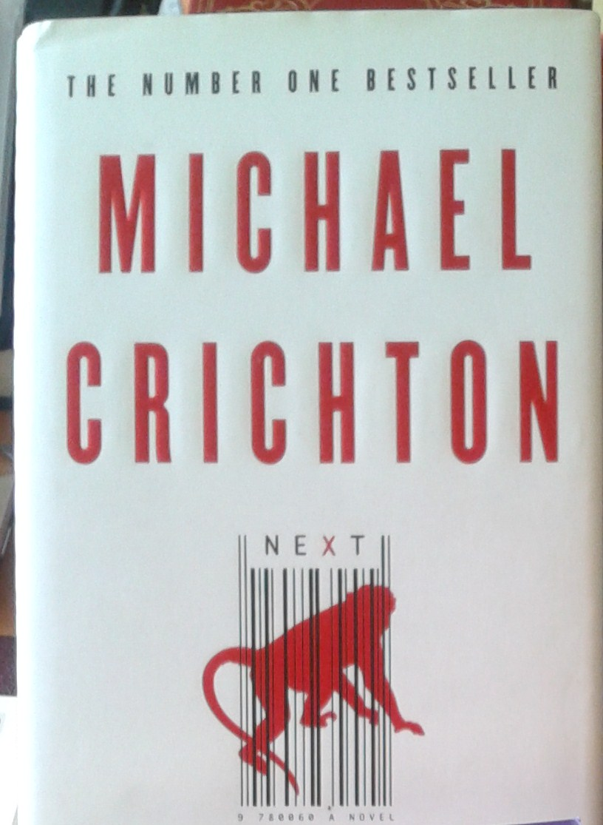

And then you are told. Write one grammatical error and it will mean certain death to your manuscript.
Only perfectly edited manuscripts need apply.
Hello, if we could afford an editor, we would probably already have an agent and a publisher who would then provide an editor.
D’oh.

Control.
A famous author recently described her latest book cover. Despairing, she says, it has nothing to do with the story

I saw a classic example of this recently.
I seriously hope Stieg Larsson is not focusing his other-worldly attention on the French covers, of his Millennium series. Maybe he’s too busy searching for coffee and sandwiches. No disrespect, I loved his books but it was impossible not to notice that not a single square meal had been devoured by his characters until the middle of the third book.
Stieg, I had apoplexy on your behalf when I saw the latest cover for book 1 in French bookstores. It shows Wednesday Addams and various other less
discernible characters.
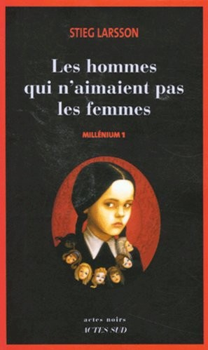
The men who don’t like women.

To use a much over used expression. WTF?
Original title in case you have been living on the planet Zog, is. The Girl with the Dragon Tatoo. How the hell did this happen? It’s outrageous!

So should you hand over your precious cargo to an agent, a publisher or graphic designer et al?
Would you hand over your nine month old baby to a complete stranger and say here do whatever you like with it?
Okay a bad example and one reason I never have children because, probably after nine months I would be saying to someone, anyone, here take it, feed it morning, noon and during the night. Attention seeking little... you get the picture.

Now don’t get me wrong. I am a lovely, caring, empathetic person in small doses and well suited to my part time occupation as a live-in carer/ housekeeper/cook/driver/ bottle washer/ temporary plumber and electrician.
But I am a sprinter, not a long distance runner.

I have moved thirty times but now I intend to stay. Why? Because I have passed the six months, itchy feet, benchmark. Usually six months into my new abode and I wake up thinking. Next !
Not here. If I wake up at five a.m. and the last thing I really want to do is to get out of bed but I can’t resist I get up to look at the view. My view. It’s been ten months and I’m still smitten.



So what has this got to do with rules?
Simple.

To rent a place in France you need a steady income and proof of such. Papers, documents, lots of them. Preferably be married or have a fall guy somewhere to provide back up. France still has equality issues, despite it being part of their national pledge. At least earn income within France so that the powers that be, can get hold of your income. For example. Payment of local taxes. A friend discovered her account had been deducted by the amount she had neglected to pay.
So let’s see. You’re single, female, self employed, working outside France.
Yep, that just about breaks every rule and yet here I am.

Richard Branson once wrote a book, Just Do It! He is so right.
Do not focus on obstacles and what ifs. See your goal clearly and go for it. Determination and perseverance. You will need both in bucket loads.

Then someone comes along and says. Your novella is a mixture of novel and a screenplay. It can’t work. Readers won’t like it.
Well here’s the thing.
Readers won’t like kindle. No comment.
Publishers will never just discover you.
You need an agent to get a publisher. Not the other way round.

Then one day. It all comes together...
And when it comes to trends and you want to be setting them not following them. My advice? Just do It!

